Presentation Preference: Poster/Oral (please delete as appropriate)

Title of Abstract Arial 16pt centred
Author¹ & Author²
¹Affiliation, City, Postcode, Country
(email@address.co.uk)
²Affiliation, City, Postcode, Country
(email@address.co.uk)

Write your abstract here. No more than 300 words. Font Arial 12pt. Single spaced. If you have more than one paragraph, do not add blank lines between them. If you have figures, add one blank line between the text and the figure. Ensure you have the right to use the figure if it is not your own. You may add more than one figure but all text and figures must fit within one page. Send your abstract to ycsec2020@gmail.com by 14th January 2022. More information here: http://ycsec2020.co.uk/abstract.html. Early Bird Registration £85 (register by 14th February 2022 at https://www.eventbrite.co.uk/e/16th-uk-young-coastal-scientists-and-engineers-conference-ycsec-2022-tickets-84749844065). Late Registration fee: £100.

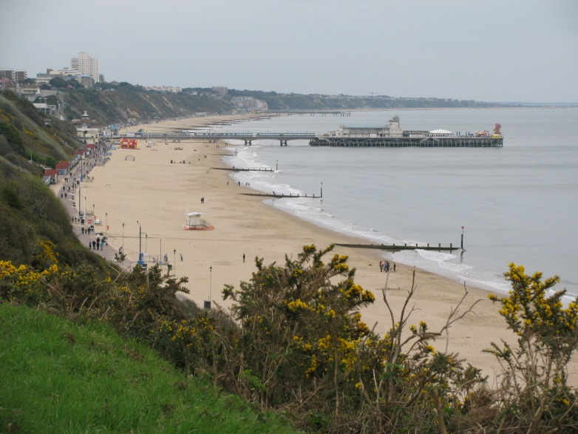

Figure 1 – Add an informative caption and ensure you have the right to use the image or illustration. Use Arial 10pt italic.

